
Project Name: Property Management System
Client Name: Noida Authority
Residential Department

North Shore Technologies Pvt. Ltd.
_________________________________________________________________
Logix Techno Park ♦ Sector 127 ♦ Noida – 201301 ♦ India
Phone : (120) – 404 3401

Contents

Introduction 4
Purpose & Objectives 4
User Classes and Characteristics 4
Residential – Complete Process 6
1. Allotment Process 7
1.1 Scheme Creation 8
1.2 Adding property(s) to the scheme 8
1.3 Scheme Notification to Public 8
1.4 Customers submits application 8
1.5 Adding Customer details 8
1.6 Approval for Successful Applicants 8
1.7 Allotment Letter Issuance 8
1.8 Business Rules for Allotment 8
2. Request for Lease Deed Execution 10
2.1. Payment of Allotment Money 10
2.2. Failure to pay allotment money 11
2.3. Time period for lease deed 11
2.4. Lease Deed Executed 11
2.5. Initiation of Lease Rent 11
2.6. Business Rules for Lease Deed 11
3. Request for Possession Certificate 12
3.1. Customer Submits Application 13
3.2. Approval from engineering department 13
3.3. Re-Adjustment of Change in Area 13
3.4. Business Rules for Possession 13
4. Request of Completion Certificate 14
4.1. Customer Submit the Completion Certificate Request 14
4.2. Validation from Planning & Account Department 14
4.3. Business Rules for Completion Certificate 15
5 Request for Transfer of Property 16
5.1 Customer Submits the Application 16
5.2 Validation from Accounts & Legal Department 17
5.3 Customer pays transfer charges 17
5.4 Approval from Manager 17
5.5 Transfer Deed Executed 17
5.6 Business Rule for Transfer of Property 17
6 Request for Issue of Mutation (Substitution) 20
6.1 Customer Submits the Application 20
6.2 Validation of Documents 20
6.3 Approval from Manager 20
6.4 Business Rules for Mutation 21
7 Request for Mortgage 22
7.1 Customer Submits the Mortgage Request 22
7.2 Validation from Account department 22
7.3 Approval from Manager 23
7.4 Mortgage Letter Issuance 23
7.5 Business Rules for Mortgage 23
8 Request for Change in Constitution (CIC/CIS/CIN/COD) 23
8.1 Customer Submits the Application 24
8.2 Validation from Account Department 24
8.3 Approval from Manager 25
8.4 CIC Letter Issuance 25
9 Miscellaneous Rules 26
9.1 Surrender 26
9.2 Cancellation 26
9.3 Restoration of Plot after cancellation 26
9.4 Extension of time for construction of plot 26
9.5 Co-Allottee 27
10 Payment Schedule Logic for Residential Department 27
10.1 Payment Schedule Formulae 27
10.2 Dues Calculation 29
10.3 Miscellaneous 30

Introduction

New Okhla Industrial Development Authority plays a significant role in building the world class infrastructure which is situated in the vicinity of Delhi NCR. It plays a significant role in development of infrastructure within its defined geographical boundaries. The development of the infrastructure includes the Residential development, Commercial development, Residential development, Residential/Residential development, Group residential development, roads and transport infrastructure development and horticulture development. Considering the potential growth rate of NOIDA, an optimized business processes are needed to serve the customers with different establishments like housing, residential, commercial, institutional, group housing and industrial.
Currently the property management system in NOIDA is being managed on the web builder database. The business processes for different kinds of service delivery is effective but lacking in the efficiency. In the current working system the technical framework is old and almost obsolete. The data management system is in the physical form and important wing of the authority like planning, engineering has no effective system to manage their activities. There is a complete lack of interface at authority level for internal communication with departments. The existing web builder system shall also run for certain time as determined by the Authority during the transition period. Effective business processes are required across the different entities\departments of Noida to attain the desired level of efficiency and ensure better services to the customers\end customers. The need is to bring an integrated database which allows the work processes to be performed efficiently and introducing a tool or dashboard for higher management/officers to monitor the activities.

Purpose & Objectives

The overall purpose of this project is to build up an integrated system which will bring the efficiency to the work flow processes. The system would primarily facilitate access on the web browser, e-enabling of various processes across and allow adoption of comprehensive approach towards gaining the efficiency. The system would enable the Noida staff officials, working assistants and end customers to access the integrated data from different business processes. It would share the relevant information across the different departments which will help in making operational as well as strategical decision.

User Classes and Characteristics

The functioning of the department is classified on the basis of the below specified roles under the residential department for better understandability:
- Manager Level
The manager is a key role whose prime responsibility is to validate the requests received from the assistant level. After the successful validation of the request, the manager level passes on the approval or the cancellation.
The manager will approve/reject the request received from assistant after getting the direction from the below departments:
  - Account Department
  - Legal Department
  - Engineering Department
  - Planning Department

- Assistant Level
The assistant is responsible for all the activities of residential department and also involved in processing all the property request received from the customer. He is also responsible for maintaining the important letters associated to the allottee properties.

- Customer Level
The customer is involved in each activity of the property process model and is responsible for submitting the requests along with required documents to the assistant for the initiation of the same.

Residential – Complete Process

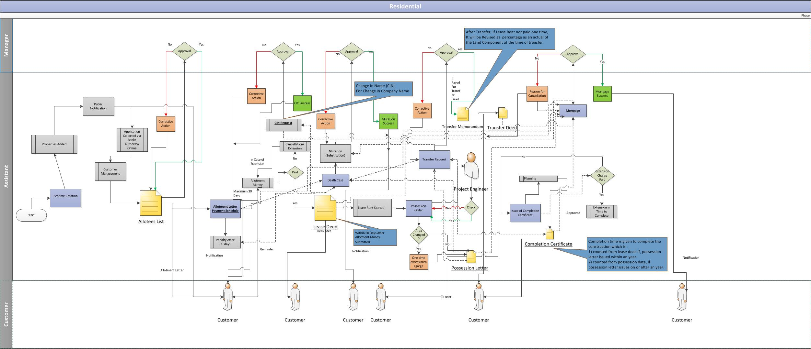

Allotment Process

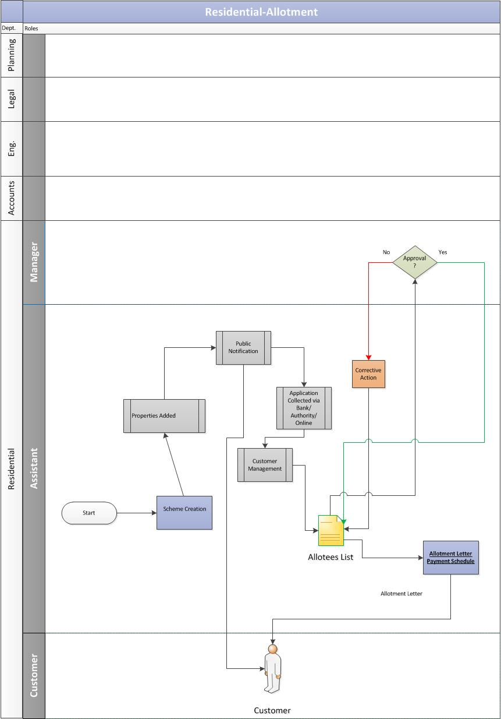

Scheme Creation
- The foremost step is classification and the creation of the schemes looking at the demographic region for the residential sectors at Noida.

Adding property(s) to the scheme
    - The assistant adds the property details under the newly created scheme. These property details are shared by the planning department.

Scheme Notification to Public
    - Post adding the properties to the respective scheme(s), the authority rolls out the scheme to the general public. This public notification contains the detailed information about the respective residential scheme. The types of draw based schemes are Villager Scheme (5% Abadi) and Open Public Schemes.

Customers submits application
    - The applicant submits the application form along with the required document and fee to the registered bank for the Draw Based Schemes and Villager Schemes.

Adding Customer details
    - The assistant would add the details for all the applicants, received from the bank, into their respective system for draw based schemes.

Approval for Successful Applicants
    - Post customer management, the applicants are selected on the basis of draw. The list of successful applicants is prepared and sent further to manager for his approval.

Allotment Letter Issuance
    - Post approval of the allottee list from the manager, the allotment is done for all the successful applicants. The allotment letter along with payment schedule will be issued to the allotees.

Business Rules for Allotment

As per the policy, some percent of the available plots are being allotted to the applicants prescribed under the categories on basis of seniority and balance is are being allotted to the general category through the draw. The persons following under categories are below:
- Eligible bonafide functional industrial units allotted/transferred on or before defined date and located in the respective region.
- Eligible bonafide functional commercial establishment allotted/transferred on or before defined date and located in the respective region.
- Eligible bonafied functional private institution located in NOIDA/Trustee/ functional directors excluding charitable/religious institutions.
- Eligible villager whose land has been acquired.
- Eligible employee of the Authority.
The basis of eligibility of the applicant is as under:
- The applicant should be competent to contract.
- The applicant/spouse/dependent should not have been allotted in full or in part on lease hold or free hold or hire purchase tenancy agreement basis any plot/house/flat by NOIDA. The dependents will not be eligible for the allotment of the individual plots.

Allotment of additional area of plot/strip adjoining the plot:

- If the area of the plot indicated in the allotment letter is issued by the authority or actually handed over to the allottee is found to be in excess or less than they are applied for, a proportionate change in amount of premium would be made.
- In case of no provision of the respective scheme, the allotment of the additional plot shall be made at the prevailing sector rate.
- In case the excess are is increased by some percent in original area, the rate would be payable at the prevailing sector rate.
- Allotment if the additional strip of the land available for the allotment adjoining the plot would be made after getting the recommendation from planning department. The allotment of the additional strip will be made at the prevailing sector.
- In case the allottee has encroached the authority land while constructing the plot, such encroached land may be allotted to the allottee after getting the recommendation from the building Cell Department on the double rate of the prevailing sector.

Request for Lease Deed Execution

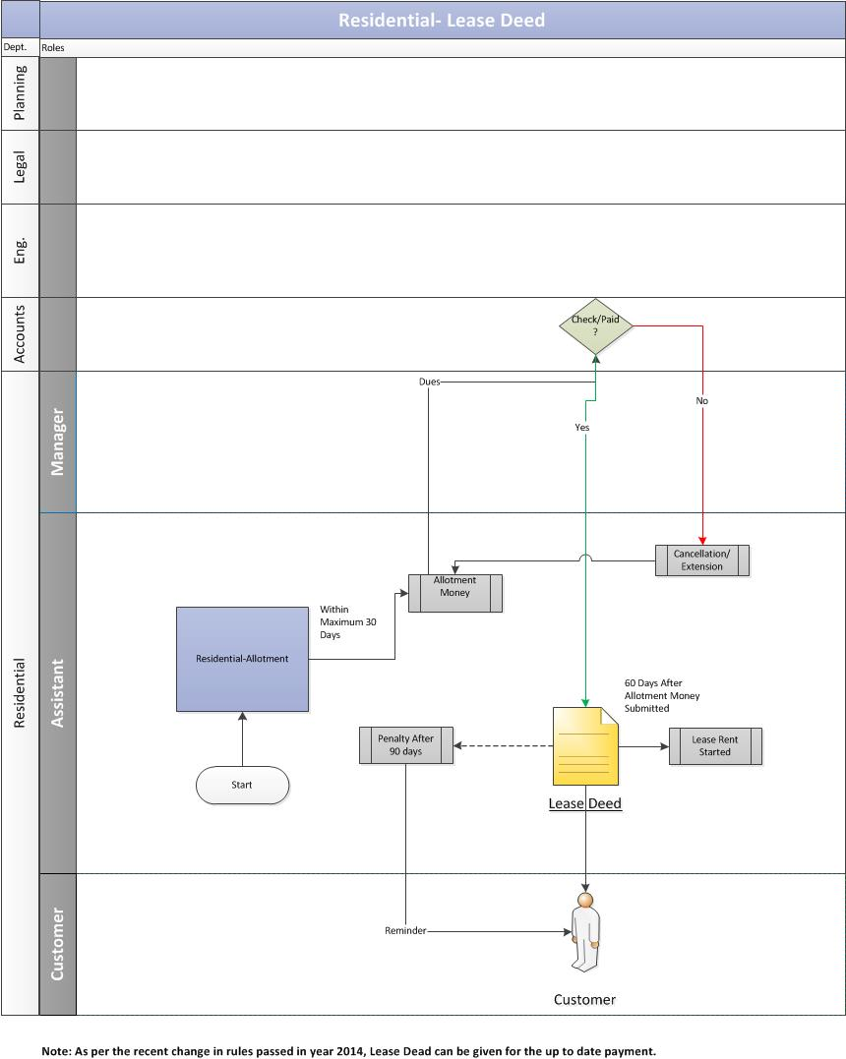

Payment of Allotment Money
  - Post the allotment process, the allotment money needs to be paid by the customer to the authority within span of 30 days.

Failure to pay allotment money
  - If the allotment money is not submitted within 30 days to authority then it may lead to below scenarios:
    - Case of Extension: If the customer is unable to submit the allotment money within time period of 30 days after allotment letter is issued, then he/she is liable to pay the penalty charges for extension.
    - Case of Cancellation: If the customer is unable to submit the allotment money within 30 after allotment letter is issued, then it may result in cancellation of allotment.

Time period for lease deed
  - After the allotment money has been received by the authority, the customer would be eligible to get the lease deed executed for the allotted property within 60 days. The customer would be liable to pay the penalty if he misses the respective time period of 90 days (30 days after allotment money + 60 days of lease deed execution).

Lease Deed Executed
  - In case of timely filing the request, the lease deed is executed by the authority to the customer and one copy of the lease deed is sent to the residential department for maintaining their records.

Initiation of Lease Rent
  - After the successful completion of the lease deed, the lease rent starts.

Business Rules for Lease Deed
- The allottee is required to execute the lease and get same registered with the authority and to take over the physical possession of the plot within defined period as mentioned in the checklist after submission of the required document.
- In case the lease deed is not executed within the given time frame then penalty would be imposed per day. The allottee shall have to bear the stamp duty, registration charges and other legal expenses.
- One time lease rent/10 year lease rent is added to the plot premium while calculating the stamp duty. The rate of the stamp duty is subject to change from the sub-registrar, NOIDA regarding calculation of stamp duty shall be final and binding on the allottee.

Request for Possession Certificate

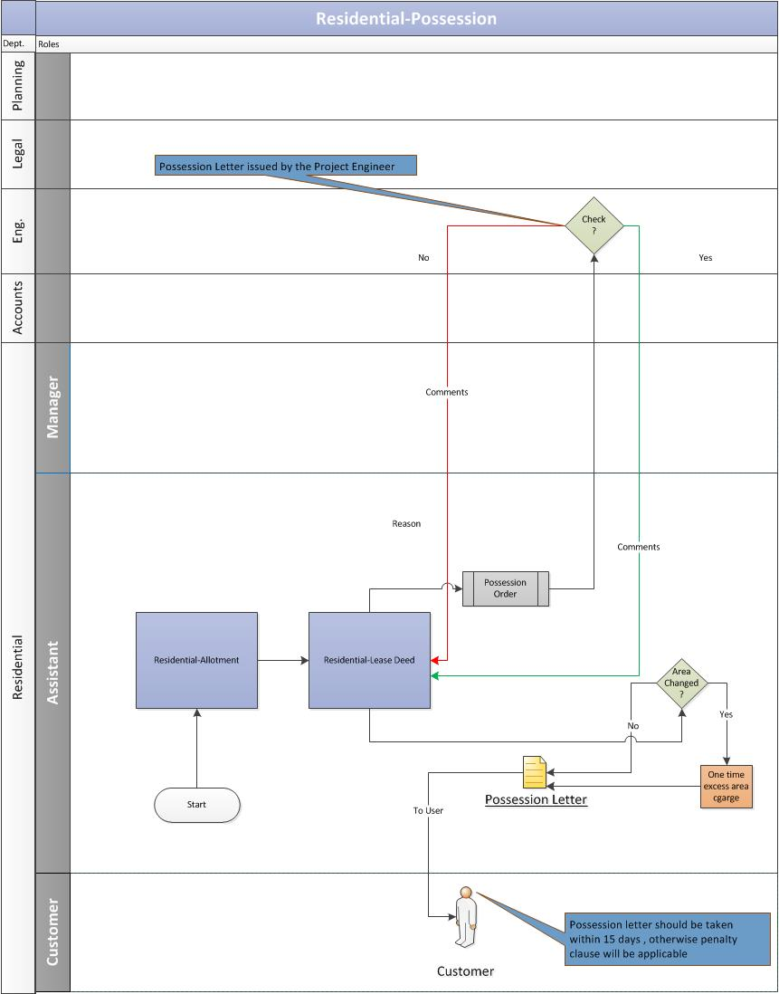

Customer Submits Application
  - The customer duly submits the application along with the required documents to get the possession certificate for the property.

Approval from engineering department
  - Assistant would validate the documents of the allotted property and send the possession order to the project engineer for further action:
    - If the project engineer does not approve the possession order, then he/she is required to send the valid reason to the assistant.
    - If the project engineer approves the possession order, the assistant will issue the possession letter to the customer.

Re-Adjustment of Change in Area
  - If there is a change in the property area during the possession phase, the assistant would readjust the area amount and would notify the same to the customer.
    - In case of increase in area, the assistant would calculate the excess amount and ask the customer to pay the same as a one-time payment. Once the customer pays the one-time excess amount, he will be issued the possession certificate.
    - In case of decrease in area, the assistant would the re-adjust the amount and reschedule the installments of the customer.

Business Rules for Possession
- The allottee is required to execute the lease and get same registered with the authority and to take over the physical possession of the plot within defined period as mentioned in the checklist after submission of the required document.

Request of Completion Certificate

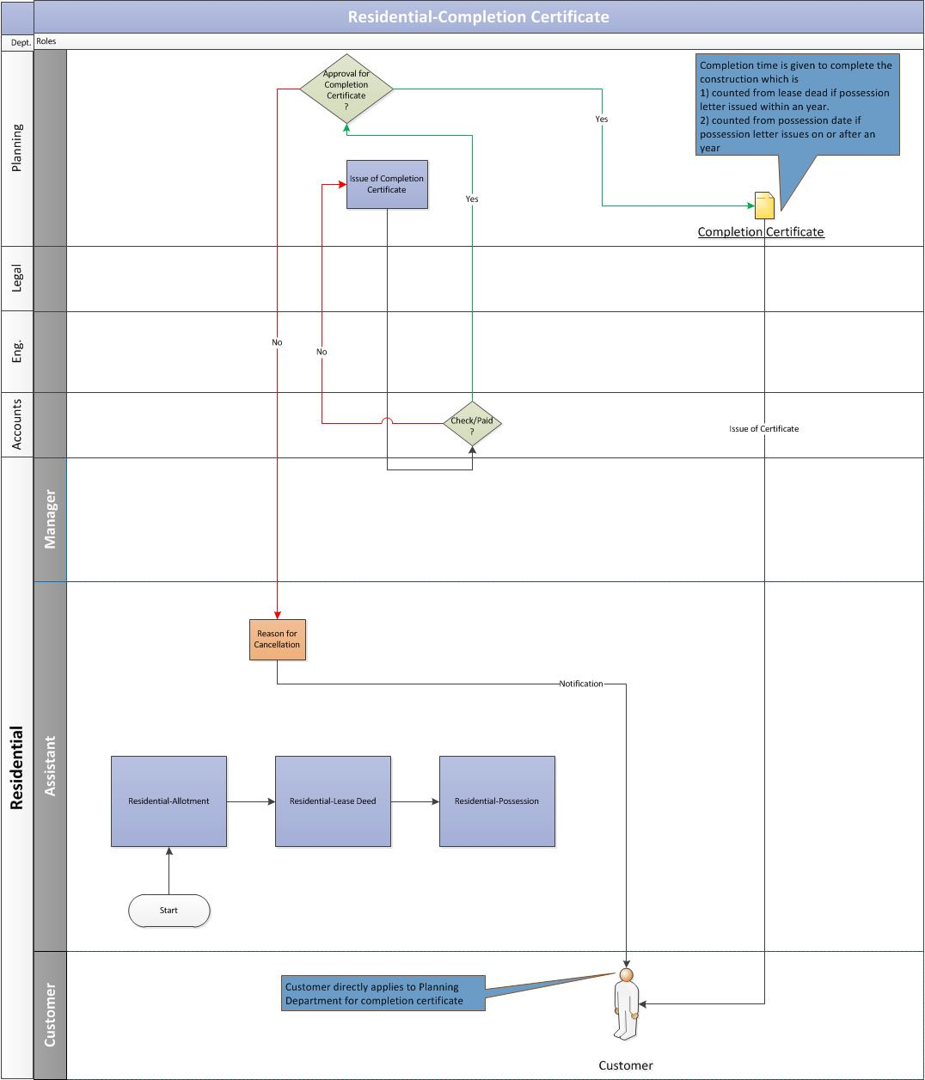

Customer Submit the Completion Certificate Request
  - The allottee duly submits the completion certificate request along with the required documents to the concerned department at Noida Authority.

Validation from Planning & Account Department
  - The Planning department receives the completion certificate request and would validate the allottee’s documents.
  - The planning department verifies with the accounts department whether the customer has paid for the completion charges:
    - If the completion charges are paid by the customer and the account department gives a go-ahead then the Planning department would issue the completion certificate to the customer.
    - If the completion charges are not paid by the customer then the Planning department would not issue the completion certificate to the customer.

Business Rules for Completion Certificate
- It is mandatory to get the completion certificate issued after lease deed is executed for property within a defined timeframe.
- If the completion certificate is not issued then extension charges will applied up to date.
- It is mandatory to have the completion certificate before the transfer of property.

Request for Transfer of Property

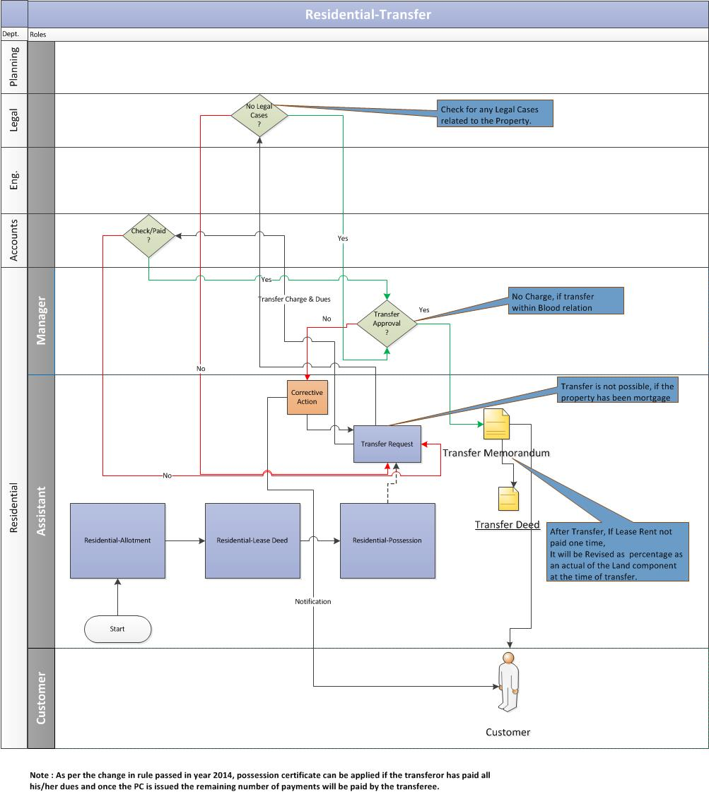

Customer Submits the Application
    - The transferor (allottee) of the property submits the transfer application request to the respective department at the Noida Authority.

Validation from Accounts & Legal Department
    - Assistant would receive the transfer request and validate the allottee’s account details and litigation details to the concerned departments.
      - The account department would verify the allottee’s account details. In case of no pending dues, the account department would issue a No Dues certificate.
      - The legal department would verify if there are any legal cases on the property. In case of no legal cases, the legal department would issue a clearance certificate.
    - Post verification from the accounts and legal departments, the assistant would ask the customer to pay the transfer charges.

Customer pays transfer charges
    - The customer pays the transfer charges and updates the same to the authority.
    - The assistant verifies the transfer payment details with the account department.
    - After receiving the payment confirmation from accounts, the assistant would send the transfer request to the manager for his approval.

Approval from Manager
    - Once the manager approves the transfer request, the assistant would issue the Transfer memorandum to the customer.

Transfer Deed Executed
    - Based on the transfer memorandum, the transfer deed will be executed.

Business Rule for Transfer of Property

- An individual is allowed to acquire more than one property from open market and get it transferred in his/her name or name of his/her spouse or dependent children, if he/she has been allotted property from authority through a scheme. The following conditions shall be applicable for permitting the transfer of the property:
  - The case where cancellation has been affected are not eligible for transfer.
  - Pre-possession cases are not applicable.
  - Only bonafide lessee are eligible to transfer the plot.
  - The transfer application is valid for six months only.
  - The transfer application form should be duly filled in along with the NOC’s of the concerned department of the authority.
  - The allottee is required to submit the lease deed/transfer deed, allotment letter and possession letter in original.
  - The prevailing sector wise allotment/transfer charges may vary from time to time.
  - Transferor and transferee should jointly satisfy themselves about the overdues/dues in position from the Account department at the authority.
  - Once transfer is approved, the liabilities of the transferor till date of transfer will pass onto the transferee. The transfer charges can be deposited either by transferor or transferee.
  - Transferee is required to clear the outstanding dues at NOIDA prior to transfer request of property.
  - Lease rent at the time of issue of transfer memorandum would be revised as defined percentage of premium calculated at the rate of allotment applicable at applicable at time of transfer memorandum, subject to revision after every 10 years. In case one time lease rent is paid then lease rent is not payable.
  - Occupancy certificate of the plot should be issued or valid extension of time for construction should have been approved at the time of transfer. After transfer of the plot, further extension of time of construction will be granted as per defined percentage of prevailing sector rate.
  - Transfer charges once deposited will not be refunded, however in case, transfer does not materialize due to dispute between the parties, or withdrawal of transfer application by the transferor with the consent of transferees then defined percentage transfer charges shall be deducted and balance amount would be refunded.
  - The transfer deed shall also be required to be executed within 60 days from the date of issue of transfer memorandum between the transferee and transferor. On the receipt of the certified copy of the transfer deed registered with the authority, a certificate confirming the acceptance of the transfer deed shall be issued as proof of the plot have been mutated in favor of the transferee.

Transfer Cases through General Power of Attorney

- Transfer of plot is allowed is allowed on the basis of the GPA/Special Power of Attorney. The applicant is required to submit the below documents along with the transfer application form:
- Registered copy of the GPA/SPA with certified copy duly notarized.
- Registered copy of the sale agreement with duly notarized for office record.
- The allottee is required to submit lease deed/transfer deed, allotment letter and possession letter in original.
- Affidavit on the prescribed Performa on non-judicial stamp paper.
- In case of the first sale, the transfer charges will be applicable at defined percentage by the authority. The amount of transfer charges shall be increased by normal charges for successive sale involved in transfer. For evaluating the single transaction the GPA/SPA to sell should be executed.
- The power of attorney holder of the prepossession plot can also apply for transfer of plot but he shall be required to execute the lease deed of plot under the transfer on behalf of the allottee before his application for transfer of plot is processed.

Transfer under Blood Relation

- The transfer under blood relation is allowed from allottee/ transferee to wife/husband, son/daughter, father/mother and vice-versa is permitted without charges.
- Incase post-possession plot is being transferred in blood relation then transfer deed shall have to be executed within 60 days from date of such approval.

Transfer of Plot in case of death of allottee

- Transfer of plot is permitted in name of the legal heir after death of the allottee without any transfer charges if under blood relation i.e. In favor of the father/mother, husband/wife, son/daughter and vice versa.
- Incase plot is being transferred in favor of the following relations, such permission will be granted subject to the fulfilment of the prescribed formalities and on payment of transfer charges equivalent to defined charges of applicable in case of transfer of plot these charges have been considered on basis of the attorney:
- Son/Daughter of deceased allottee
- Brother/Sister of deceased allottee
- Brother’s Widow
- Grand Mother/Grand Father/Maternal Parents
- Brother/Sister of Fathers/Mothers
- Incase allotment/lease of plot is transferred in favor of person outside the above mentioned relations on the basis of registered will of deceased allottee or on basis of probate order from courts defined transfer charges i.e. Equivalent to charges payable in case of transfer of plot through power of attorney shall be payable.

Request for Issue of Mutation (Substitution)

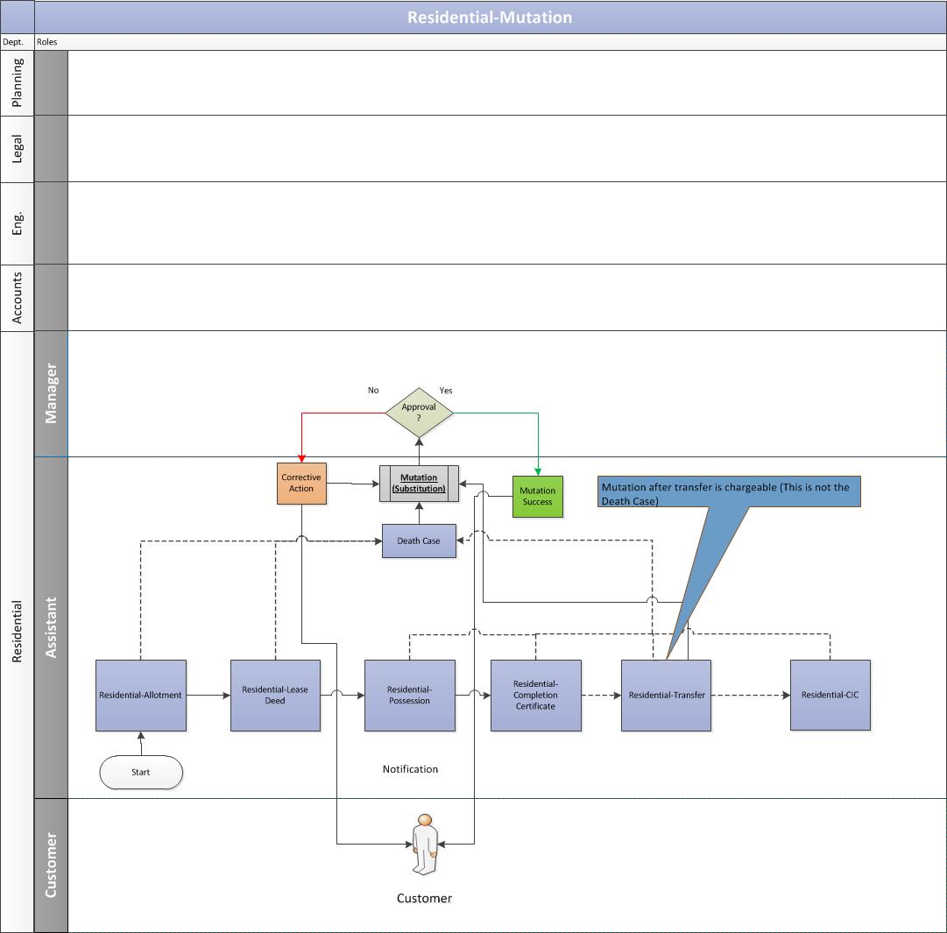

Customer Submits the Application
    - If the owner of the property dies then the transferee/beneficiary of the property submit the application along with required documents at the residential department of the authority.

Validation of Documents
    - The assistant receives the mutation (substitution) request and validate the application and documents attached to it.

Approval from Manager
    - If the papers are in place, the assistant would send the mutation request to the manager for his approval:
      - If the manager approves the mutation request, the assistant would issue the mutation letter to the customer.
      - If the manager rejects the request, a notification would be sent to the assistant. The assistant would then share the same with the customer.

Business Rules for Mutation
- Mutation letter of plot is issued to the allottee after submission of certified copy of the transfer deed in compliance of transfer memorandum issued and after checking that transfer deed executed is in order or as per terms of the memorandum.
- In case the transfer deed is executed through the GPA/SPA, additional charges would be payable to authority. This mutation letter is issued to transferor in respect of property.
- Mutation after transfer is always chargeable however in case of death it is not chargeable.

Request for Mortgage

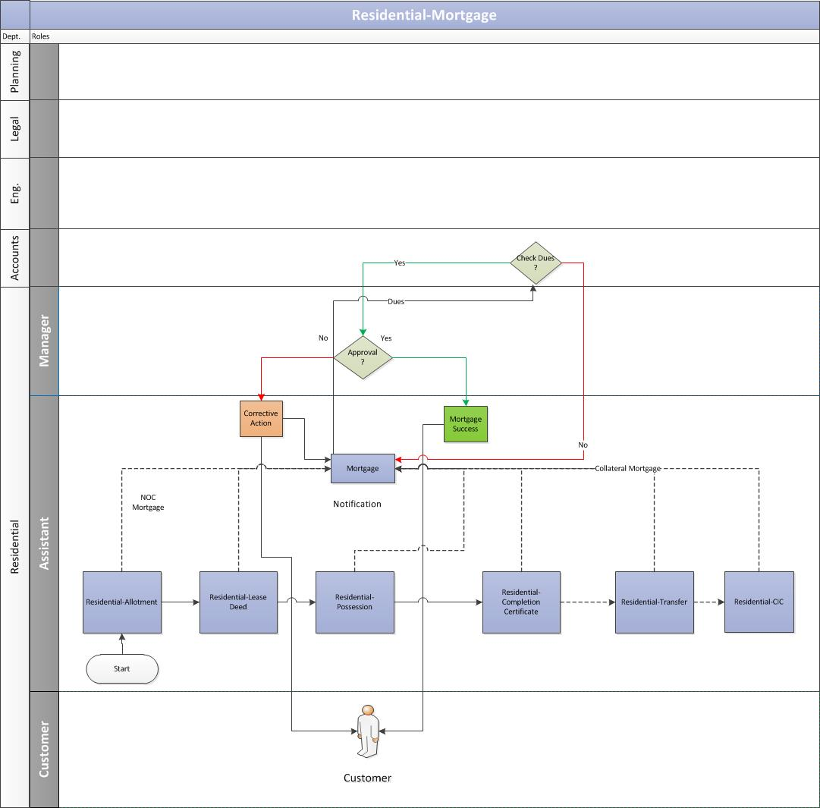

Customer Submits the Mortgage Request
    - The allottee duly submits the mortgage request along with the required documents, for the construction or re-construction on the plot allotted, to the concerned department at Noida Authority.

Validation from Account department
    - The assistant receives the mortgage request and would send the same to account department to validate the allottee’s account details for any pending dues.
      - The account department would verify the allottee’s account details. In case of no pending dues, the account department would issue a No Dues certificate.

Approval from Manager
    - After receiving the confirmation from accounts, the assistant would send the mortgage request to the manager for his approval.

Mortgage Letter Issuance
    - Once the manager approves the mortgage request, the assistant would issue the Mortgage letter to the customer.
    - In case any previous mortgage exists, the assistant would notify the customer to clear the previous dues first before applying for fresh mortgage.

Business Rules for Mortgage

- The mortgage permission is granted (where plot is not cancelled or any show cause notice is not served) in favor of bank/govt. organization/approved financial, institution for construction of plot on receipt of simple request of the allottee. The allottee shall have the valid time period for construction as per terms of lease deed or have obtained valid extension period.
- Allottee will submit following documents: Sanction letter of bank, affidavit of non-judicial stamp paper stating there are no unauthorized construction.
Mortgage of property in shape or equitable or collateral security
- Equitable mortgage and permission for collateral security is granted if plot premium and due amount of lease rent has been paid and occupancy certificate of plot has been issued.
- The allottee is required to pay the processing fee.

Request for Change in Name

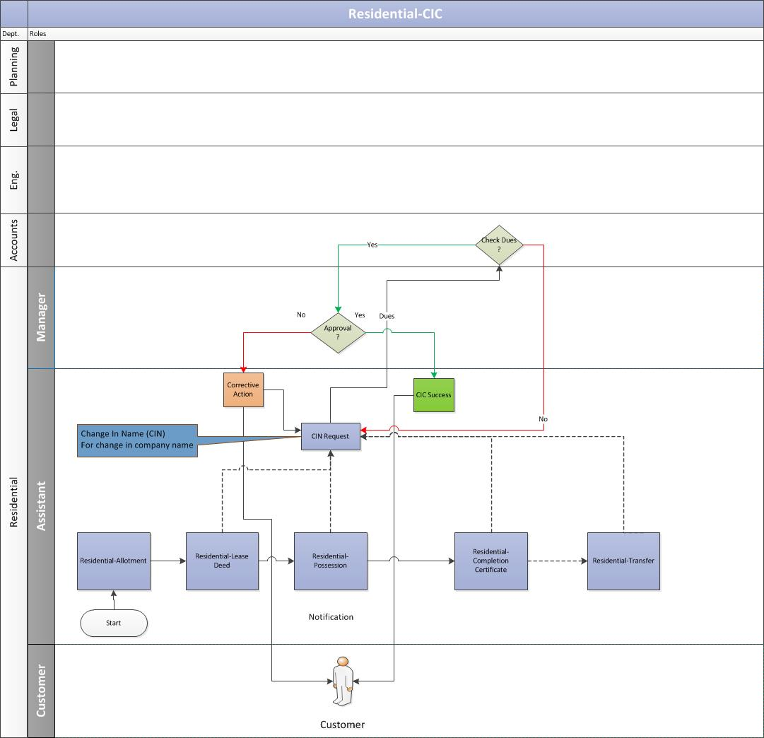

Customer Submits the Application
    - The allottee duly submits the application along with CIN charges with required documents to the authority.

Validation from Account Department
    - The assistant receives the CIN request and would send the same to account department to validate the allottee’s account details for any pending dues.
      - The account department would verify the allottee’s account details. In case of no pending dues, the account department would issue a No Dues certificate.
      - In case any previous dues exists, the assistant would notify the customer to clear the previous dues first before applying for the CIN letter.

    - Post verification from the accounts departments and if no dues exists, the assistant would ask the customer to pay the CIN charges.
    - The customer pays the CIN charges and updates the same to the authority.
    - The assistant verifies the CIN payment details with the accounts department.

Approval from Manager
    - After receiving the payment confirmation from accounts, the assistant would send the CIN request to the manager for his approval.

CIC Letter Issuance
    - Once the manager approves the CIN request, the assistant would issue the CIN letter to the customer.

Miscellaneous Rules

Surrender
    - The allottee has the right to surrender the allotment before initiating the cancellation of plot.
    - After approval of surrender in post-possession case, the allottee shall be required to execute surrender deed.
    - In case of surrender deed approval, entire amount deposited towards the plot shall be refunded after deducting only processing fee.

Cancellation
- If the allottee/lessee fails to deposit the due money within the given time or such extended period as is allowed or commits any breach of terms and condition as laid down in the brochure of respective scheme/allotment letter/lease deed, the allotment/lease shall be liable to be cancelled. In such event the amount deposited towards the plot will be refunded after forfeiture is done as per defined percentage. Possession of plot with the structure if exists thereon, shall be resumed in favor of authority and allottee/lessee shall not be entitled for the claim.
- If the allotment/lease of the plot is obtained by any misrepresentation, suppression of material fact, misstatement or fraud, allotment/lease may be cancelled determined and the possession of plot and building thereon may be resumed and allottee will not be entitled to any compensation. The entire money will be forfeited in favor of authority.

Restoration of Plot after cancellation
Normally restoration of plots is not allowed. In exception cases, restoration can be allowed by the CEO or any other authorized officer. Defined percentage of the charges are levied
- In pre-possession cases where cancellation is exercised for default in payment of half yearly installment.
- Post possession case where cancellation of allotment and revocation of lease deed has been done in the consequences of the breach in conditions.

Extension of time for construction of plot
Extension charges for grant of extension of time for construction after expiry of defined period in lease deed of plot, is payable as under:
- First to third/fourth years of the extension of time is granted as per terms of lease deed of plot subject to the payment of extension charges as mentioned in lease deed.
- Further extension of time, beyond the permissible extension period mentioned in the lease deed can be granted up to defined timeline subject to payment of extension charges.
- Extension of time without charges is granted to those allottees who are central/state officers, government officers/officials and after.
- After transfer of plot, further extension for construction will be granted on payment of extension charges equivalent to defined percentage of the prevailing sector rate per year.
- Incase advance extension of time has been approved as per terms of the lease deed of plot and plot being transferred, the allottee shall be required to pay deficit extension charges from date of transfer.

Co-Allottee
- Making co-allottee is only permitted if proposed co-allottee is in prescribed blood relation of allottee.
- After getting the approval in post-possession case, the allottee shall execute transfer deed or any other document as per satisfaction of the authority within a defined time-frame (currently 60 days) of transferring such permission.

Payment Schedule Logic for Residential Department

Payment Schedule Formulae
The calculation of the payment schedule for Residential would be done using Reducing Monthly Installments. The formula for the same is as follows:

Total Premium Balance Amount = Total Cost of property – (allotment money + earnest money)

Principal Amount= Total Premium Balance Amount/No. of Installments

The first installment in reducing monthly installment method can be calculated as:

First Installment Interest Calculation = [Total Premium Balance Amount * (Rate of Interest/Frequency)]/100

Premium Balance Amount = Premium Balance Amount - First Installment Principal Amount

From First Installment Interest onwards,
Second Installment Interest Calculation = [Balance Premium Amount *(Rate of interest/Frequency)]/100

Premium Balance Amount = Premium Balance Amount - Second Installment Principal Amount
Similarly,
Nth Installment Interest Calculation = [Balance Premium Amount *(Rate of Interest/Frequency)]/100

Premium Balance Amount = Premium Balance Amount - nth Installment Principal Amount

Payment Schedule Example
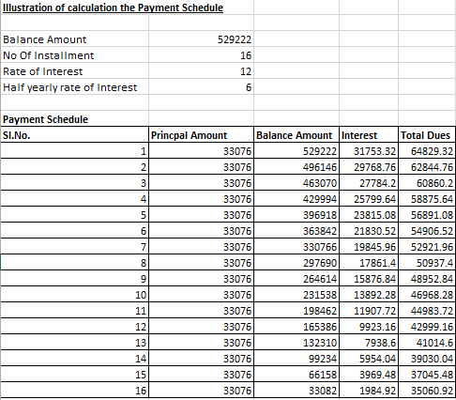

Dues Calculation

Example 1 - Part Payment Calculation
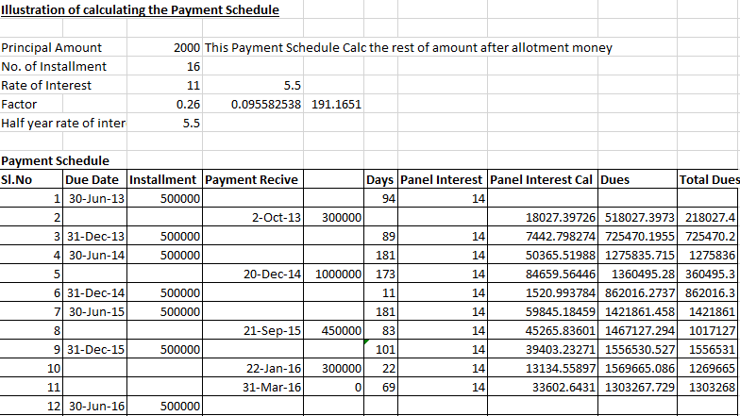

Example 2 – All Payments Outstanding Calculation
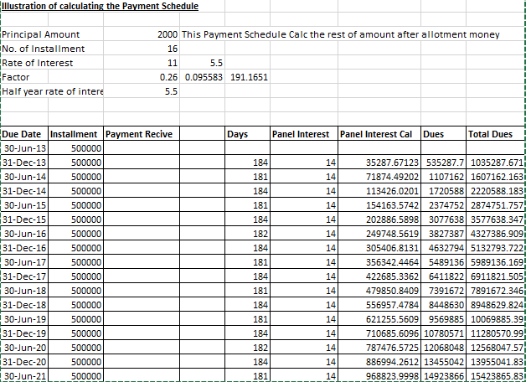
Note:
  - For the first six months (from 1st January to 30th June), the number of days for calculating the daily interest would be 181 days. In the case of leap year, the number of days for calculating the daily interest would be 182 days.

  - For the last six months (from 1st July to 31st December), the number of days for calculating the daily interest would be 183 days.

  - The panel interest will be applicable if the payments are defaulted.

  - If a person defaults, then penal interest would be applied to his outstanding payment. Penal interest can be calculated as

p*(1+r/100)^n

where, P = Principal
r = rate of interest
n = frequency

Miscellaneous
It is mandatory to get the lease deed executed for property after allotment is made within a defined time-frame (Currently 30 days).
Post that, penalties will be levied on the citizen based on the below formula:
Penalties = [(One Year Lease Rent)/365) * no of default days +one year lease rent]

Note: After every 10 years lease rent will be revised.

